Guideline for Financial Reporting

Introduction
The purpose of this document is to provide guidance on financial reporting for organizations with project/program agreements with Union to Union.
Please observe the changed dates in the Addendum to the original cooperation agreement.

Reporting requirements
In order to fulfil the requirements for reporting, the following reports must be submitted to Union to Union:

Midterm report - Not applicable in 2025.

Annual and Financial report
Documents, as listed below, for the activity period (1 January– 30 September 2025), shall be submitted to Union to Union no later than 30 November 2025.
The total report must include:
- Final narrative report on results 2023-2025 and financial outcome 2025 (Union to Union template)
- Follow up of the project’s objective matrix 2025 (free format)
- Activity matrix 2025 (Excel-file from application)
- Financial outcome and transfers on the Union to Union template (Excel-file from application)
- Transfer_Details_2025 on the Union to Union template
- Partner Organisation contact information (if revised from application)

and

- Auditor Report according to ISA 800/805 including the financial outcome on the Union to Union template (excel-file from application) signed by the auditor
- Audit Report on factual findings according to ISRS 4400 signed by the auditor
- Management Letter from auditor to Agreement holder organisation
Management Response by Agreement holder organisation on Management Letter (shall be submitted no later than 15 December 2025.

Required contents in the Budget/Outcome excel-file
Reports should be drawn up using the same excel template with budget items as in the approved budget in the agreement.
Be sure to use the updated template for the narrative report, i.e., the template on Union to Union’s website (http://www.uniontounion.org).
The narrative report shall include comments relating to the figures in the “Budget/Outcome” excel-file. If costs are reported on another level or item than the budget explain why. Always comment on the outcome in relation to the budget.
A list of partners in the project chain is included in the narrative report stating if there are agreements holders for transfer of funds with local or regional partner in the project chain, with the amounts in those agreements (Question 7). Comment on any exception from audits or transfers of funds, refer to the approval agreed upon.

The predefined budget lines/cost types (keywords)
- Administrative costs
The administrative costs can include for example part of the office rent, stationery, and costs for necessary IT equipment as well as bank charges. It can also be costs for finance staff who work with the accounting and financial reports.
- Audit
Audit costs can be estimated and included in the financial report of the program or project even if they are not prepaid. If the final costs deviate from the estimation, the difference may be charged to the project the following year, if the project is multi-year. If the project ends and the estimated cost exceeds the final cost, the surplus, including interest, must be repaid at the time were any outgoing balances or interest revenues are repaid.
- PME
Planning, Monitoring and Evaluation involves costs that do not benefit the target group directly but are necessary for the implementation and reporting of the project/program, for example costs for planning the project, travel costs for field visits, internal evaluations etc. External evaluations shall be noted as a separate budget line.
- Staff/ personnel costs
Project coordinator, organisers and other staff employed in the project are examples of project staff costs. Above listed roles should not be listed as separated budget lines unless they for example are employed for a specific event/expert role/workshop
Staff costs shall be accounted for and allow reviewing and auditing. The costs should be charged on a regular basis and authorized by the appropriate person. The basis for any estimated staff costs must be clearly documented and commented on in the narrative report. Estimates alone are not sufficient.
National accounting and tax rules must be complied with.
Voluntary work does not qualify as a project/program cost.
All project/program costs must be possible to trace in the accounting and there must be supporting documents.

Budget vs Outcome
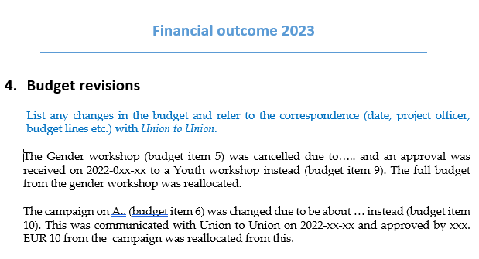
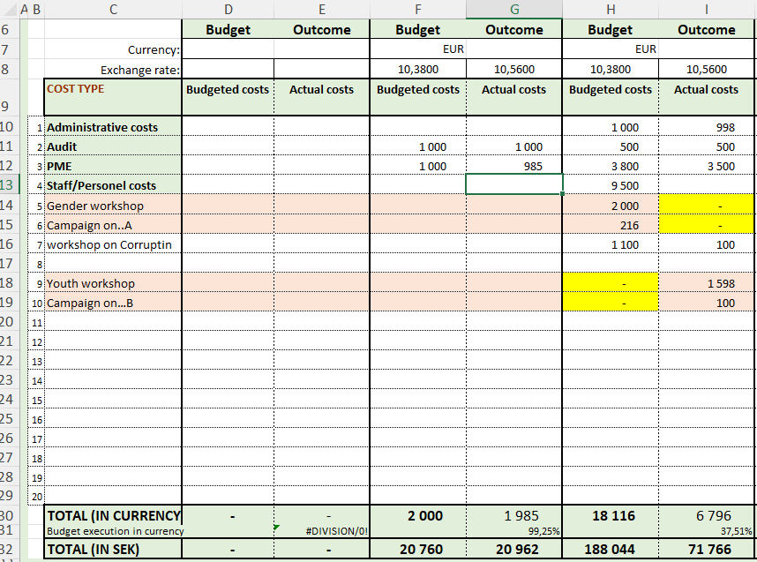
- Use the same excel template with budget items as in the latest approved budget in the agreement (the version that includes a revised budget column can also be used). The financial report must compare outcomes with the latest approved budget (Question 6). It must include comments in the year-end report on major budget deviations (those in excess of 10 percent per budget line, provided the deviation exceeds an amount corresponding to SEK 10,000).

- To ensure a clear tracking of budget deviations (Questions 5 and 6), any new budget items shall be added in a row under the already approved budget items. The budget amount for the new item shall be noted as 0 (zero), only the outcome amount shall be filled in (se example above).

- A comment must be made in the financial narrative report stating (se example above)
    - when the approval for this was received
    - which previous budget item the budget was reallocated from
    - the approved budget amount for the new budget item.
The same principle applies whether it is within a level or between levels.

- Financial accounts must be presented using the same currency as in the approved budget.
- The exchange rate for the outcome must be filled out in the template (or the connected sheets will not show any results).

The exchange rates used in the report for each level can be calculated as:
  - On each level an average yearly transfer exchange rate is calculated from transfers amounts received/made during the year.
  - If that is not possible, the average exchange rate against SEK for 2024 can be used to calculate the rate. Verify the history of the local currency concerned for the above period https://www1.oanda.com/currency/converter. The value in SEK for the Outcome will then be according to that average transfer rate.
The final value of the outgoing balance will be calculated at an end of year rate by Union to Union and notified to the agreement partner in the Project Report Memo.

Comparison between where costs are audited and where they are attributed
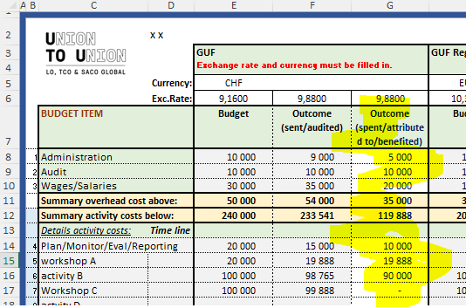
The “Budget_Outcome_template_2023 GUF-updated” file includes sheet “2B.Sent vs Spent”. This sheet copies the figures entered in the “2.Budget and Outcome” sheet (which includes a Revised Budget column) and has a column Outcome (spent/attributed to/benefited). This sheet is for analysis purpose only and its use is optional.

Multilateral projects – costs on level 2
If the Swedish unions have costs related to the projects, an invoice has to be sent to the GUF with supporting documents and they shall be reimbursed by the GUF. These costs shall be noted in a separate budget line on the level where the outcome is audited. This will clearly show the amount that is related to the Swedish affiliate.
If costs are noted on level 2 (as in old excel templates) an audit must be made for level 2 and sent to the GUF and included in the GUF audit. The cost for the level 2 audit shall not be included in the project costs.

Cost per country
List all countries where costs have occurred. This is not in the audit chain, but countries where activities etc have taken place. This sheet is for analysis purpose only.
The table automatically deducts the budget/outcome for the GUF HO leaving the remaining funds to be distributed per country. If there is an amount left in “Remains to be distributed” please explain why (Question 10b).
If costs are related to a regional office, please note costs for the country where the office is as well as the countries in that region where costs have occurred. Cost should be related to where the activity has taken place, not from where any participants come from.
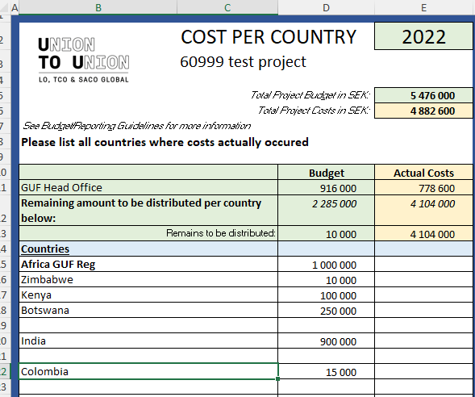

Transfers received and sent (Question 8)
For each level note the amount of money that was requested and received, if needed please add a new row, use the Excel file “Transfer_Details .xls”.
If funds are transfers from a lower level to a higher (level 5 to 4) this must be commented on separately in the annual financial report.
Only transfers of project funds in the project chain of Agreements should be noted. Please note especially for level 5 that reimbursements of costs for minor costs are not the same as Agreements for transfers of funds in the project chain. Only transfers that induces audits or have an exception from audits are eligible here.
Please fill in the figures in the excel file, not in the narrative report template. Any comments should be written in the narrative report.
Please note that this is the summary of the transfers and average transfer rates that correspond to the “Transfer and Balance” excel sheet in the Financial Report.
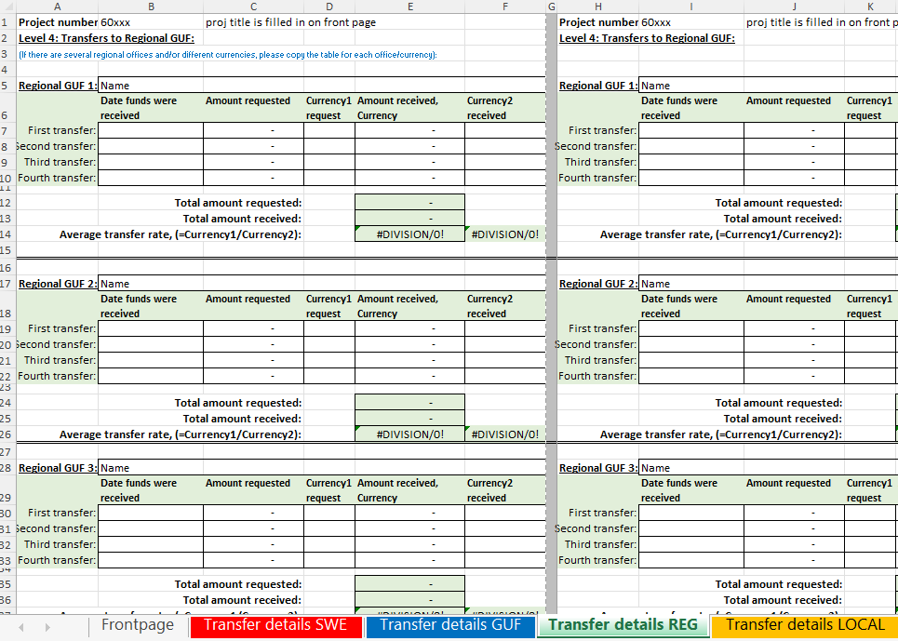

Interest revenues
The Co-operation Partner may keep surpluses resulting from interest. The interest shall be used to finance activities in line with the approved objective. Interest revenues related to projects or programmes shall be included in the financial reports.

Signing of report
The financial report must be signed by the auditor and authorized signatory in the organisation on the relevant sheets in the template. Those sheets (“Budget and Outcome” and “Transfer and Balances”) applicable have lines for the auditor visible when printed.

Exchange rates gains or losses (Question 9)
Any gains or losses resulting from changes in currency exchange rates should be accounted for in connection with the annual reporting.
- Comments should be made on the impact on the outcome of the project costs (for example: were any activities added or cancelled?).

- Comments should also be made on the exchange rate gain or loss in the closing balance for each level.
Compare the end of year rate with the average exchange rate of transferred funds (on each level) and write the amount/s in the narrative annual financial report. The end of year rate according to www.oanda.com per 31st December shall be used as comparison.
For each level comment on the exchange rate gain or loss in the outgoing balance by using the average transfer rate and the end of year rate.
Example: | Outgoing balance (currency) | Value at transfer rate in SEK | Value at end of year rate in SEK | Gain / loss in SEK
Level 2 | 0
Level 3 | -564,20 CHF | -5 675,85 | -5 783,05 | -107,20
Level 4 | 0
Level 5 | 797,43 EUR | 8 022,15 | 8 173,66 | 151,51
Example on level 5 for how to arrive at the numbers above:
  - Average transfer rate for three transfers = 10,06 SEK/EUR
  - Per 31/12/2023 the SEK/EUR the end of year exchange rate was 10,25 SEK/EUR
  - Outgoing balance as noted in “Transfer & Balance”-sheet, in this example it is EUR 797,43
  - Value at transfer rate = SEK value against the average rate is entered, i.e. the same rate that corresponds with the outcome rate in “Transfers and Balance” = 10,06 => SEK 8 022,15
  - Value at end of year rate = SEK value against the end of year rate = 10,25 => SEK 8 173,66
  - Calculated gain/loss is then 8 173,66 - 8 022,15= SEK 151,51

Additional requirements for organizations forwarding funding
- Organizations forwarding funding must ensure that agreements are signed with partners at subordinate levels, and that these agreements contain the applicable sections of the agreement with Union to Union.
- The Organization must ensure that when funding has been transferred to subordinate levels, it is audited according to the Agreement and Audit instruction from Union to Union.
- Organizations are responsible for carrying out the following at subordinate levels:
  - Assess and act on information received in reports relating to transferred funding.
  - Keep written records of decisions made about reports received from partner organizations.
  - Report any shortcomings and/or significant issues that come to light to Union to Union immediately.
  - Check agreement partners against the EU-sanction list.

Outgoing balances/Repayment of funds
The final outgoing balance in SEK for the whole project will be notified in the Balance sheet from Union to Union.

